Project Design Phase-II
Data Flow Diagram & User Stories
Date | 31 January 2025
Team ID
Project Name
Maximum Marks | 4 Marks

Data Flow Diagrams:
DFD LEVEL- 0

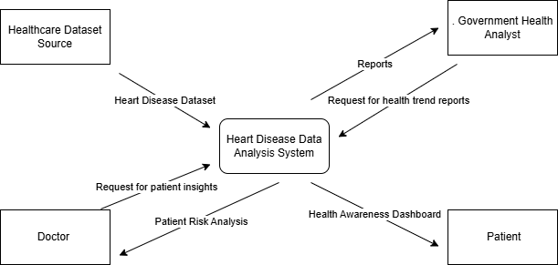

DFD LEVEL-1
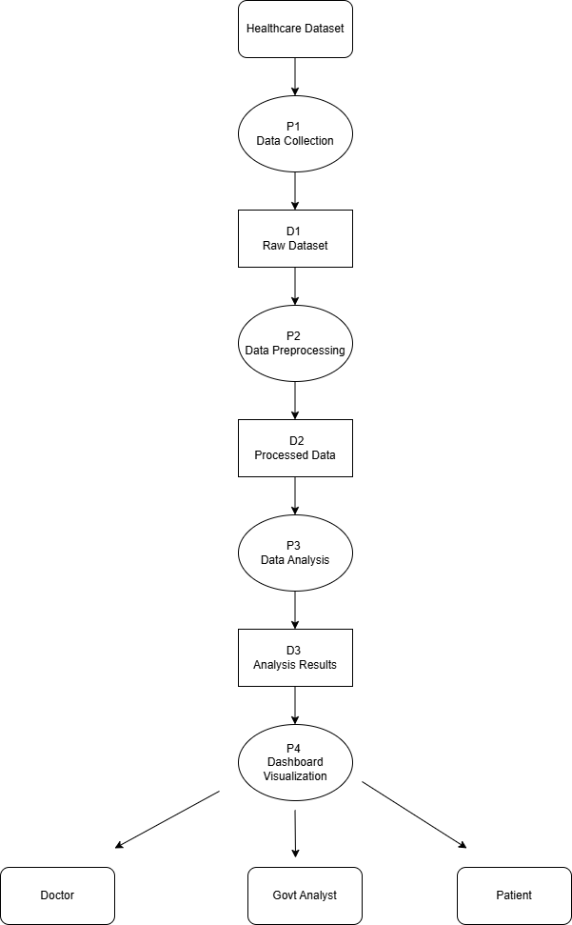

User Stories

User Type | Functional  Requirement  (Epic) | User Story Number | User Story / Task | Acceptance criteria | Priority | Release
Doctor | Dashboard Access | USN-1 | As a doctor, I want to view a dashboard displaying patient health indicators such as cholesterol, BMI, and blood pressure so that I can identify high-risk patients quickly. | Doctor can open dashboard and view charts of heart disease risk factors. | High | Sprint-1
 | Data Filtering | USN-2 | As a doctor, I want to filter patient data by age, gender, and medical indicators so that I can analyze risk factors for different patient groups. | Doctor can apply filters and the dashboard updates automatically. | High | Sprint-1
Health Analyst | Trend Analysis | USN-3 | As a health analyst, I want to analyze heart disease trends using visual charts so that I can identify patterns and risk factors in the population. | System generates charts showing heart disease statistics and trends. | High | Sprint-1
 | Report Generation | USN-4 | As a health analyst, I want to export analytical insights and reports from the dashboard so that I can share findings with healthcare authorities. | User can download or view reports generated from dashboard data. | Medium | Sprint-2
Patient / Public User | Risk Awareness | USN-5 | As a user, I want to view simplified visualizations of heart disease risk factors so that I can understand how lifestyle habits affect my heart health. | User can view easy-to-understand graphs showing major risk factors. | Medium | Sprint-2
System Administrator | Data Management | USN-6 | I want to upload or update the heart disease dataset so that the dashboard always reflects the latest health data. | Admin can upload new datasets and system updates dashboard automatically. | High | Sprint-1

